**Digitalizing Healthcare Architecture**

**An Engineering Project in Community Service**

**Phase – II Report**

***Submitted by***

**Harsh Rajoo Selukar - 20BCE10393**

***in partial fulfilment of the requirements for the degree of***

***Bachelor of Engineering and Technology***



**VIT Bhopal University**

**Bhopal**

**Madhya Pradesh**

**March, 2023**



**Bonafide Certificate**

Certified that this project report titled **“Digitalizing Healthcare Architecture”** is the bonafide work of “20BCE10302 Sudhanwa Bokade” who carried out the project work under my supervision.

This project report (Phase II) is submitted for the Project Viva-Voce examination held on **9th March 2023**.

**Supervisor**

**Dr. VVPRVB Suresh Dara**

**Comments & Signature (Reviewer 1)**

**Dr Soumitra Nayak**

**Comments & Signature (Reviewer 2)**

**Dr Manisha Jain**

**INDEX**

|  |  |  |
| --- | --- | --- |
| **Sl. No.** | **Topic** | **Page No.** |
| 1. | Introduction | 1 |
| 1.1 | Motivation | 2 |
| 1.2 | Objective | 2 |
| 2. | Existing Work | 4 |
| 3. | Topic of the work | 5 |
| 4. | Result and Discussion | 7 |
| 5. | Individual Contribution | 8 |
| 6. | Conclusion | 9 |
| 7. | References | 10 |

**1. INTRODUCTION**

We have been handling a lot of medical indentures like prescriptions, reports, summary, bills in our life. What if we say no more of handling and keeping them arranged in your house? That will save a lot of paper which indirectly saves trees. Yes, you read it correct presenting you "Remeaitree" which reads out as:

`React Based Web App which will transform medical industry using AI

techniques and saving trees

**`**

The master idea works by creating a de-centralized website just like Digilocker but in the field of medical science with the help of two-factor authentication using aadhar and a phone number. The users can log in to the platform and see all their past reports, prescriptions, and medical history which will be visible in a structured format with an option of searching and querying.

In our current version, we will be creating a hospital or subscription-based feature in Remeaitree. This includes AI-based research on any disorders that will be adjourned using DL/ML techniques. Along with this, we will try our best to add a video conferencing application to have an online consulting session with the doctor from their home at their own convenience. The feature won't be limited here. In our future endeavors, the feature will also include BlockChain Technology for keeping patients' data safe and 1mg integration for directly getting medicine delivered as prescribed by doctors.

As we very well know that these kinds of applications can be used in day-to-day life by a few people and for those few people, it might be of occasional use. On understanding the demand and convenience of everyone, we planned to create a PWA which devours as Progressive Web Application. PWA has a unique feature of acting as both a website that can be opened via a web browser or can be added to the home screen as an application. Some prominent examples include:- YouTube [Desktop], and CodeVIT [VIT Platform].

### 1.1 Motivation

We all have seen our parents, family, and friends rushing for a medical emergency foregoing times. Searching for files or past reports at such a crucial time is similar to the worst nightmare that a person can ever think of. Sometimes, some diseases may be co-related and the doctor might need to know that before performing any forthcoming surgeries, he might need to know what has happened with a patient earlier, and most importantly, he might need to know what all doses of drugs the patient is currently pursuing. In order to handle all the processes in a better manner, we planned to create a simple application that can handle all of these. With the same, we all have even seen sometimes few places management forces doctors to work for money and waste a lot of patient's money. So, for saving this money we added the power of AI for confirming the disease and crosschecking for patients.

### 1.2- Objective

There is an old adage, ‘out of sight out of mind’. We all intermittently are liable to forget things with time and sometimes when it is much needed at that hour. By virtue of this, we came together to think of how we could contribute to the community in a better way. This project will not only make things easier for all the doctors but would also be beneficial to all the patients in the world not waste their efforts in handling all the different reports of different problems at a time. In this way, we could integrate the modern world which is mainly based on AI, with the old medicine world. AI can do wonders and we have seen many wonders in the field of medicine with the power of AI. Also helping others is not only good for them and a good thing to do, but it also makes us happier and healthier too. Giving also connects us to others, creating stronger communities and helping to build a happier society for everyone. And it's not all about money - we can also give our time, ideas, and energy.

**2. EXISTING WORK OR LITERATURE REVIEW**

We are imperatively building this project to make the system of fetching and storing reports easier. Before starting to work on it, we had to research if such software is available in the tech industry at present or not. After visiting many hospitals, we analysed that not all hospitals had a centralized system of working. Some private hospitals do have a synchronized system but that isn't available for all hospitals. We primarily will make this a decentralized system. Along with this, so far not many hospitals are implying AI support in their workplace or daily life. We additionally want the maximum number of people to get aware of this technology so implying AI is also one of our essential mottos. We are using AI support to detect the disease, and though we assure you it would detect the disease and suggest cures, still the patient will have to consult a doctor for further verification of the detected disease and its cure. We are combining different AI models into one and we are sure that this hadn't been done before but our project will change the entire existing system by easing the work. We are helping the community as a whole, i.e patients and doctors with this software.

Along with this, we are trying to implement blockchain technology which no one has used before in this field. We are implementing this just to prevent the hacking of data with the help of modern technology. We are amalgamating all the hospitals to be united for the sake of the health of a patient and this is evidently not done by anyone if the past. All that matters for every doctor are to just try his best to save the life of their patient. Instead of wasting time in getting the past reports of the patient, they can access all of it with a click, then why not? We are very well aware that it's not an easy task to gather so much data and store it but we will try our best to incorporate everything in the easiest way possible.

**3. Topic Of The Work**

1. **System Design / Architecture**

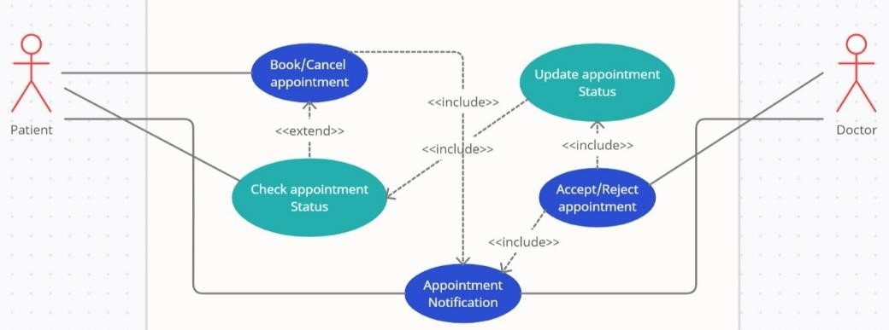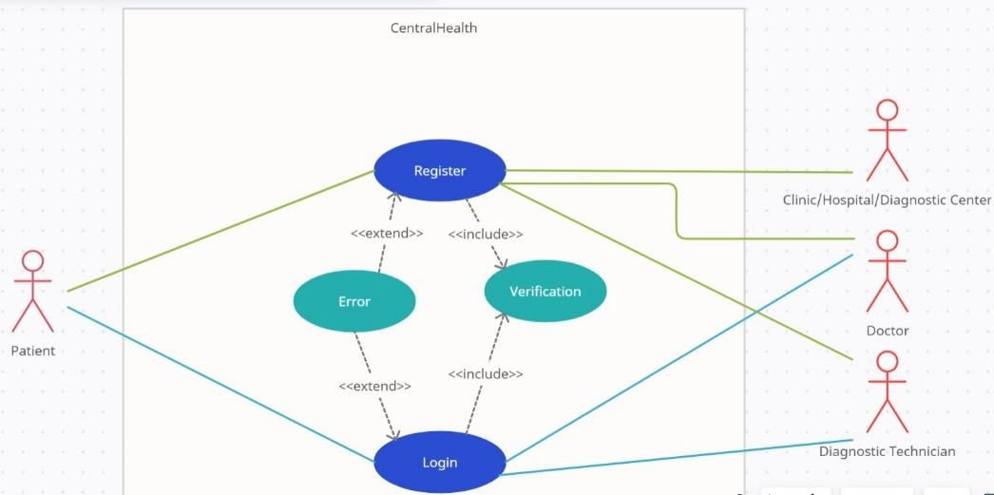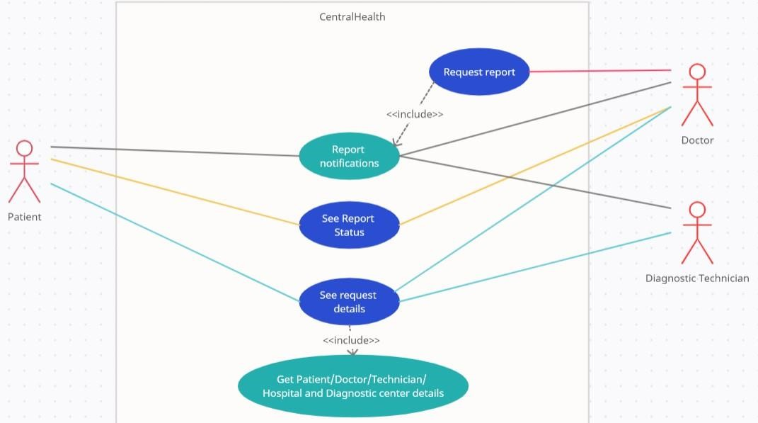

1. **Working Principle**

We are a good team together and honestly to date we are just done with several discussions of our idea and how can we make this project more effective. Along with this, we did thorough research in many civil and private hospitals on how is the working exactly done. We are clear with the complete workflow of how we will work and what else we can add in the process of making our project the best. We are also working on the making of our website and we have divided the work and will be done with it soon.

## 4. Results and Discussion

AI-based research on any disorders that will be adjourned using DL/ML techniques. The users can log in to the platform and see all their past reports, prescriptions, and medical history which will be visible in a structured format with an option of searching and querying

A long time ago our society accepted the notion of treating people with disabilities not as unviable and disabled but as differently abled, recognizing their skills beyond their disabilities. The next step must be taken by our scientific community, that is, to normalize lives of the people with disabilities and make it so as if they are no different to us. The primary step in this direction would be to normalize communication between people.

**5. Individual Contribution**

**My contribution -** In my contribution as a lead UI Designer and front end developer. My responsibility as a UI designer was to build the website's main page as well as a visually beautiful and user-friendly interface for a video calling and chatbot’s UI that can prescribe medication.

I started by learning about the best methods for creating interfaces for video calling platforms in order to develop the video calling page. I investigated numerous video conferencing tools and examined their user interfaces to pinpoint the crucial components of a successful video calling website. Then I drew multiple wireframes that prioritised usability and information clarity while also including the necessary functionality, including the chatbot and video chat choices.

I then used design software like Adobe XD and Adobe Illustrator to generate high-fidelity mockups. In order to make sure that the design was both visually beautiful and practical, I experimented with various colour schemes, font, and visual components.

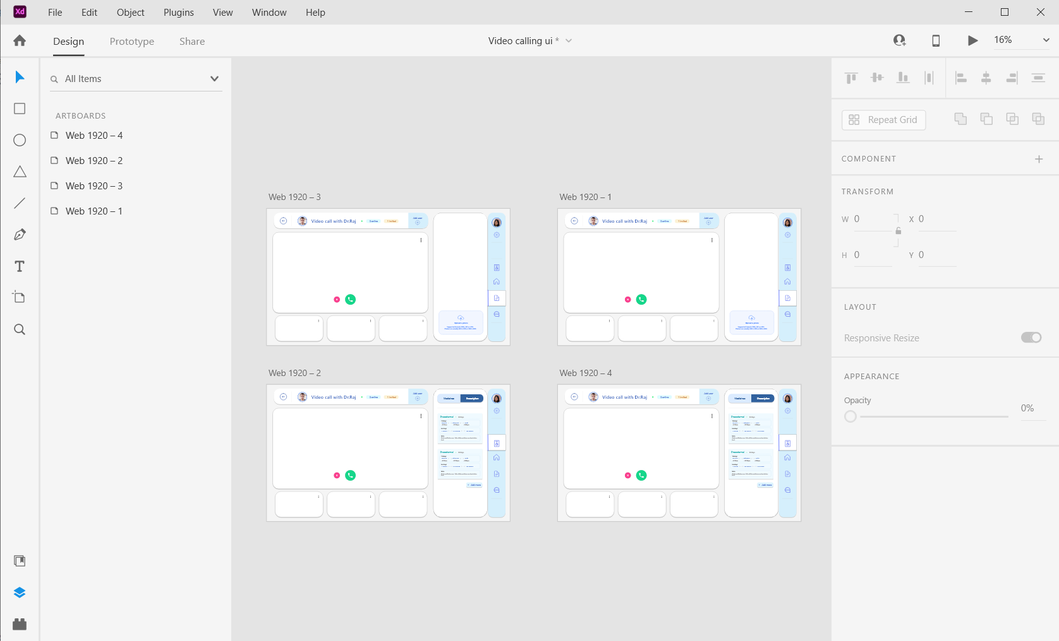

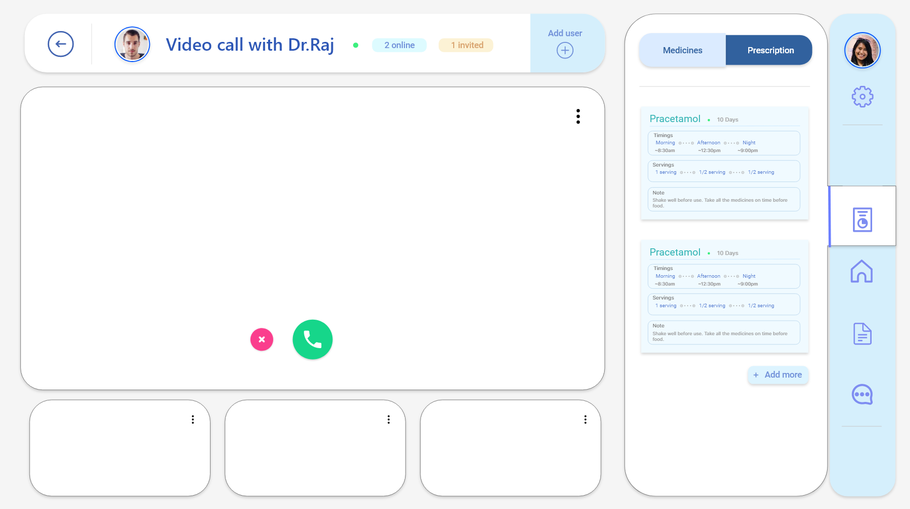

I created both the website's home page and the page for video calling. This required creating an organised layout that effectively communicates the goals and services of our project. By utilising icons, photos, and typography to convey important information, I worked to create a design that was both aesthetically pleasing and educational.

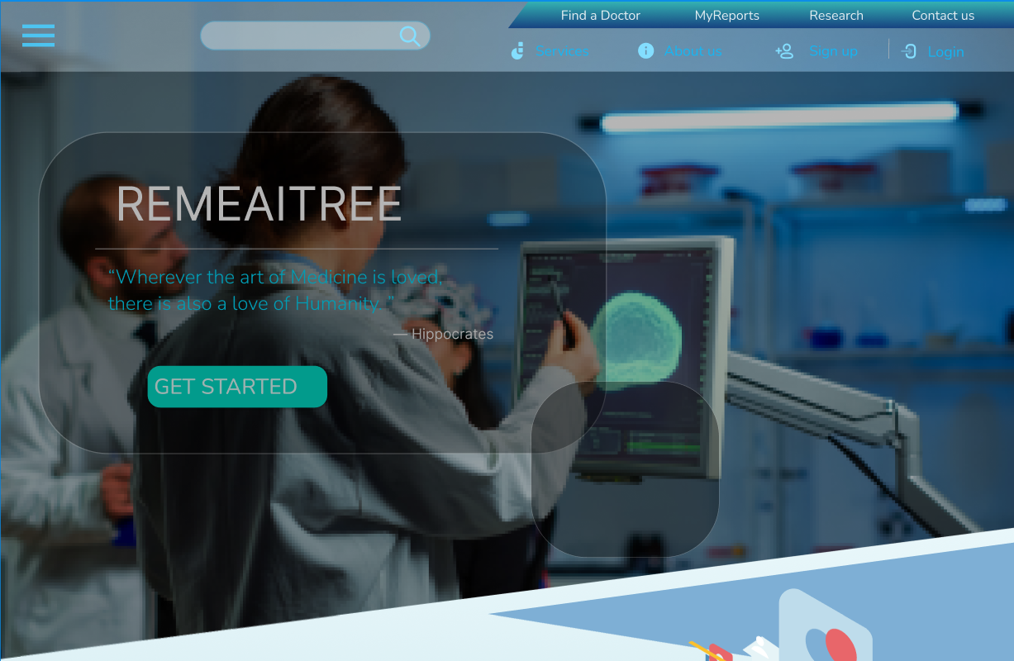

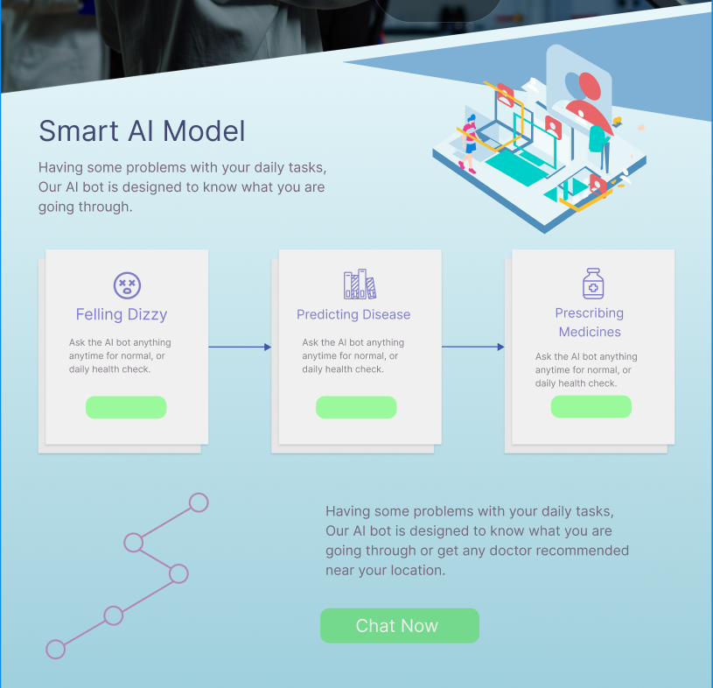

I am also currently working on the UI and the Front End part of a Chat bot who communicates with the user, who then detects their disease and prescribing then with relevant medications.

I developed the idea and design for the chatbot-integrated video calling page in addition to producing an interesting and educational home page as my overall contribution to this project. My efforts contributed to the overall project's success and helped to produce a seamless and simple user experience for the company's clients.

**6. Conclusion:**

We are a good team together and honestly to date we are just done with several discussions of our idea and how can we make this project more effective. Along with this, we did thorough research in many civil and private hospitals on how is the working exactly done. We are clear with the complete workflow of how we will work and what else we can add in the process of making our project the best. Till now we have trained the model and developed the api for the model . We have also completed the frontend of the website .The things left are integration of AI models with video feature page. While we think your suggestion could potentially benefit the project, we are confident that going with the ongoing workflow will yield much more positive results keeping all the alternative approaches into consideration

1. **References**

Following are few of the sources we have analysed and gone through and which helped us to formulate this idea:

* 1. <http://proceeding.conferenceworld.in/ESHM-2019/5RepSP9ZonR1012.pdf>
  2. [https://create.arduino.cc/projecthub/skyseeker/deaf-blind-communicationwith-1sheeld-arduino-bb3362](https://create.arduino.cc/projecthub/skyseeker/deaf-blind-communication-with-1sheeld-arduino-bb3362)
  3. [https://www.instructables.com/COMMUNICATION-BETWEEN-THEBLIND-AND-DEAF-USING-ARD/](https://www.instructables.com/COMMUNICATION-BETWEEN-THE-BLIND-AND-DEAF-USING-ARD/)